**Norfolk Snowsports Club Executive Committee Meeting No.419**

Date: 19th October 2021

Location: Ivan Palfrey Suite, Norfolk Snowsports Club

Committee: Deborah Anstee (DA); David Baxter (DB); Dudley George (DG); Caroline Gibbs (CG); Edgar Harden (EH); Rebecca Matthews (RM); Richard Oliver (R0); David Rich (DR); Richard Roberts (RR); Harry Steward (HS).

Attending: Matt Brooks (MB); Leah Fogg (LF)

|  |  |  |
| --- | --- | --- |
| **No** | **Agenda Item** | **Action** |
| **1** | **Apologies:** Kevin Rhead (KR) |  |
| **2** | **Conflicts of Interest:** None were declared against the published agenda |  |
| **3** | **Minutes of Previous Meeting - RO**  Minutes of meeting 418 were agreed. |  |
| **4** | **Welcome & Overview – RO** RO welcomed the committee to the 2021-22 term of office and the new members Caroline Gibbs, Harry Steward and Edgar Harden. The roles and responsibility of the committee were outlined along with elements of confidentiality that accompanies the role.  RO advised that Leigh Barber has resigned from the Executive Committee through work commitments. The vacancy that is created was proposed not be filled immediately and see what additional skills and expertise need to be brought to the committee before co-opting anyone into the vacancy |  |
| **5** | **Committee Operating Model – RO**  RO talked through the proposed committee members roles and responsibilities and club priorities for the forthcoming terms. Details in the document we agreed as the priorities and way forward for the Executive Committee. **See appendix 4 for reference.** The roles have been slightly updated since the meeting to reflect the role of liaising with Snowsports England under RO, DG along with KR from an instructor and coaching perspective. |  |
| **6** | **Governance and Policies – RM**  RM shared the background to the Director Code of Conduct document signed up to by the Exec committee. RM also ensured everyone had understood the documentation issued in the Welcome email and that each person understood and felt comfortable with their role. This being confirmed by each committee member signed the Director Code of Conduct. **MB/RM** to obtain signature from Kevin Rhead who was absent  RO shared a proposed Risk Register (see appendix 5 for reference) for each committee to review and provide feedback upon. Ro advised that this register needs to be more actively managed and will have a regular agenda item throughout the 2021/22 term of office | **RM/MB** |
| **7** | **Actions from Previous Meeting - RO**  Actions updated. **See Appendix 1** |  |
| **8** | **Financial Review – DBa**   1. **Financial Update for period to 30 September 2021**  * DB provided an overview of the financial management aspects of the club to the committee * The 2019/20 budget figure has been used for 2021/22 as a sound point against which to target the business * From an activity aspect Tubing is well ahead of forecast with some catchup required from Lessons, Coaching, Ops and Tasters * Wages and Salary slightly higher than normal due to some back-dated payments * RO question to higher spend in 2020 against Clubhouse running costs. DB confirmed this to be the Gladstone license maintenance that had been deferred under the agreement of Gladstone due to lockdown and club closure. * CG questioned the collecting of membership subscriptions and potential errors or shortfalls in rejection reporting from Barclays. DB/MB to investigate * CG and EH questioned the volumes of club members versus the number of memberships. MB to share figures * Large Items of Expenditure forecasted for October 2021   + New Sitski from Adaptive funds allocation - £3000   + Further adaptive equipment from Adaptive funds allocation $6.5k subject to exchange rate   + Instructor expenses backlog anticipated to be ~£10k   + November will see annual insurance premium which was proposed and agreed to be paid a single premium to avoid interest charges for a monthly payment plan * DR asked if Online banking is available to address the backlog of instructor expenses. DB confirmed it was, but the issues experienced with the BACS payment process should now be resolved and anticipated to issue expenses under the standard process * DG raised question regarding the accuracy of the last of instructor expenses. LF advised there was an error made but this has now been rectified   **See appendix 2 – Finance Report**   1. **Staff Salary Review – RO**    * RO shared the principles applied by the Operations Committee with regards to the pay review process. This being to ensure as a club we pay above the national minimum wage and remain competitive in the marketplace. Applying the principles the proposal to increase staff salaries by ~7% at an additional operating cost of £28,879.89, increasing pension contribution to £9,628.80 was approved. These additional operating costs anticipated to be offset as part of the price increases agreed at the AGM. These price increases, assuming 2019 footfall achieved, are set to deliver £65,364 of additional revenue (excluding membership)    * HS questioned how the pay differential has been positioned to recognise the additional responsibility of a Lead tubing supervisor. RO to share with HS the revised hourly rate for a tubing supervisor and Lead roles 2. **Spend Requests - RO**    * Adaptive – it is minuted the Exec Committee approval of £12,552 to be taken from Adaptive funds allocation to support the purchase of new adaptive equipment. Approval was achieved via email of the 2020/21 Exec committee members 9th September 2021. | **DB/MB**  **MB**  **RO** |
| 9 | **Club Operations Report – MB**  MB talked through the operations report **(see Appendix 3)** which covered both August and September   * August volumes were low as the club was hit by 7-10days of resource impacts through pingdemics. MB expressed his thanks and gratitude to all staff through this testing period for the club. * Summer holidays saw tubing offered over a fewer number of days/sessions to try and drive fuller and a more cost-effective operation. Additional sessions were opened based upon demand * Overall, September volumes were only 9% down from the benchmark period of 2019, with tubing showing an increase of 25% * Open practice is seeing lower numbers. For August operation open practice and activities with just travelators in use whilst the Poma lift was being serviced only saw a minimal take up * CG asked regarding non-payers for sessions. After background and discussion, it was agreed for spot check to recommence during the winter season focusing on known groups where there have been problems in the past. * MB to share slope timetable on a quarterly basis |  |
| **10** | **Maintenance Update – RO**   * One member of the Maintenance team has resigned, and a replacement being actively sought. One strong application received but when approached for interview with hours of receiving the application, the applicant had secured another role**.** * **A review of large maintenance spend had been undertaken and presented to the Exec committee as follows…**   + Snowflex order to patch and repair the Moguls and Funpark at a cost of £38, 206 + VAT   + Book Snowflex cleaning equipment for a period of 7 weeks at a cost of £11,245 + VAT It was questioned if the hire of the equipment could be brought forward from June 2022 to pre xmas 2021. Unfortunately, the equipment isn’t available for a period long enough to complete the clean of the nursey slope before the closure of its rental period running Nov 21 – Mar 22. Booking of the equipment will be attempted to be brought forward from the proposed June 2022 to April 2022. MB/RO to issue comms to instructors and Tubing supervisors advising of the additional maintenance activities that will be undertaken to try and maintain as cleaner slope as possible throughout the winter period MB to ask Briton engineering for advice re products to spray on the slope and also help neutralize the green “gunk” already built up on the matting and foam underlay   + There are currently no new spare matts to undertake any patching of the mainslope. It was requested to purchase 20 mats @£300 each (an increase from £180 per mat) at a cost of £6000. As it was anticipated that the cost of the mats is only set rise further it was agreed to purchase a total of 70 mats to allow for future refurbishment. The total cost for Techmat for the mainslope as result being £21000 + vat. A formal quote is to be obtained from Techmat encouraging a discount for an order of 70 mats/   + Replacement carriers for the Poma lift previously approved are still to be supplied by Ski Slope Services. Cost ~£4800 + VAT * Investigation continues into the current spate of outages of travelators including the replacement/upgrade of the control circuitry which are currently costing £500 each to repair. MB advised that an additional circuit breaker is to be installed as a trial to further manage to load capacity and prevent damage to the primary circuitry. These will cost £50 to install and replace. Further updated will be shared once the testing has been carried out. * EH asked if slope cleaning activity can be undertaken at night and/or with multiple shifts. Ro replied that night shift isn’t an option as its impractical and time consuming to return the slope to a usable state each. Multi shifts could work to reduce the overall end to end timescale of the closure but as it is a team of at least 6 per shift costs would be prohibitive, even if suitable resource could be found (typically club members) | **MB/RO**  **MB**  **MB** |
| **11** | **Marketing Update – MB**  MB presented the structure and approach of the current plan which showed a lower level and more proactive planning approach with a specific focus for each month RO requested that it is tracked how much business each marketing approach generates to understand the most effective marketing platform and approach.  MB to forward the plan to all committee members for review and comment at the meeting in November. MB to share a plan for validating club member email addresses | **MB** |
| **12** | **Correspondence Received – RO** The letter received from a club member regarding broader awareness of Exec Committee activities. The letter was responded to by the Executive Committee. | **RO** |
| **13** | **Any Other Urgent Business – RO**   * **Firework bucket donation beneficiary** – agreed as Boudica breast cancel appeal * **Lease Renewal** – DB shared than he and Ro are to meet landlords and their agents for initial discussion surrounding the lease renewal. DG to review current agreement and a Commercial Lease lawyer will be engaged to review final agreement Ed Bellamy has offered to take any lease documents to his colleagues to help with any negotiations. * **Race Bids** – DR shared that race bids have been submitted for GBR’s, All England and Club National for 2022. A particular win from this process is the hosting of the Club National on a Sunday as part of a double header with Ipswich where previously, Norfolk always had to take the Saturday and loose Junior Club revenue. Specific thanks to Debbie Gunton for part in this achievement. * **DG** – Head skis and Board due for delivery in November which will then trigger the invoice for the previously approved figure of £13k. * **EH** – shared feedback from ESSKIA competitors and how the club was held in such high regard but amount of algae on the slopes were commented upon. |  |
|  | **Declarations of Interest throughout the meeting**  None |  |
| **Date of next meeting…**  **Executive Meeting:** Tuesday 16th November 2021 | | |

**Appendix 1 – Action Register**



**Appendix 2 – Finance Report**

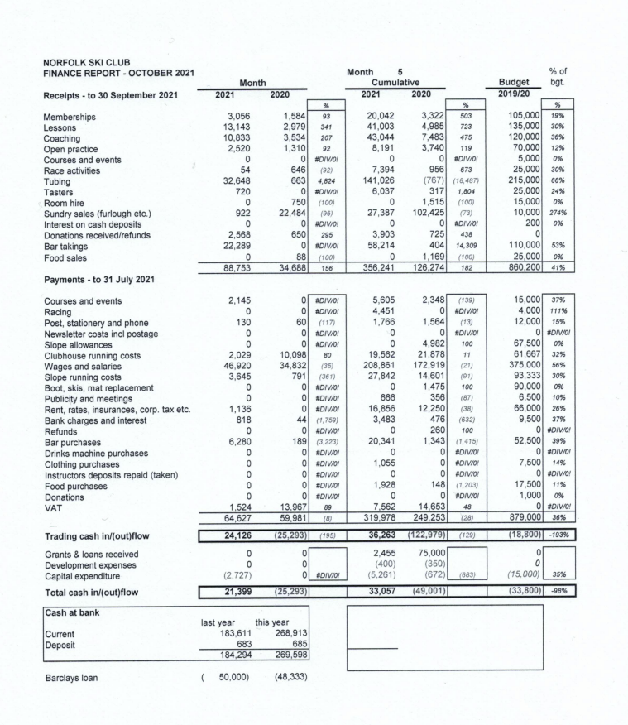

**Appendix 3 – Operations Report**





**Appendix 4 – Executive Committee Operating Model 2021/22.**

